**Cmpe 443 PRINCIPLES OF EMBEDDED SYSTEMS DESIGN**

**PRELAB #006 “TIMER”**

1. **Problem Definition**

You will use an Ultrasonic Sensor to get the distance data and based on this data, you will turn on/off Red LED on the board. When you detect a close object (10cm), the Red LED will be turned on, otherwise it will be off.

1. **Ultrasonic Sensor**

HC - SR04 Ultrasonic sensor has 4 pins which are VCC, Trigger, Echo and GND.

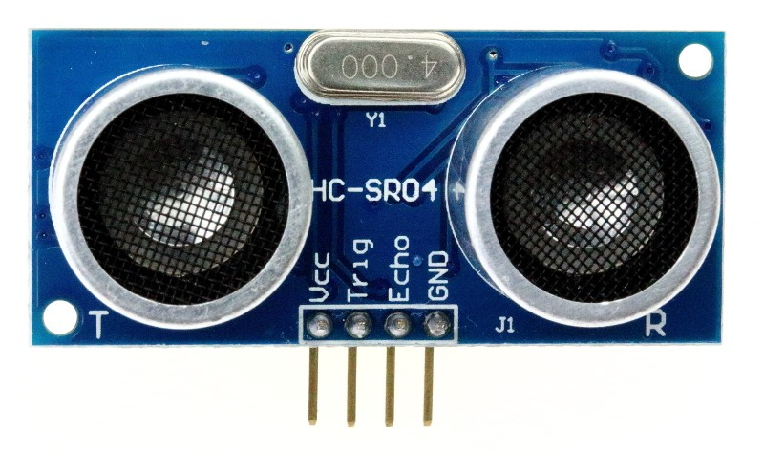

Vcc pin should be connected to 5V on the board, GND pin should be connected to the GND. For the Trigger and Echo pins you should select suitable pins.

Trigger pins are giving trigger signals to ultrasonic. Echo signal is for determining the distance.

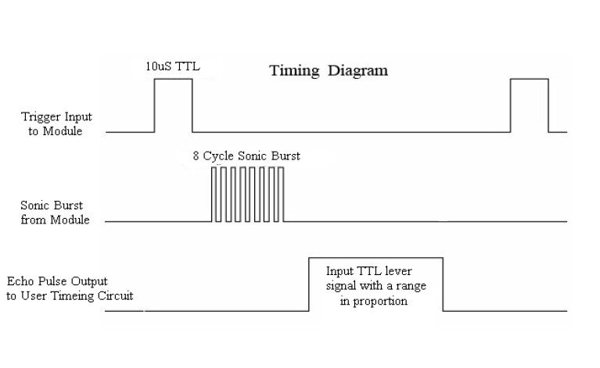

You will send a trigger signal to the ultrasonic sensor. After that ultrasonic will send 8 cycle bursts of ultrasound at 40KHz and it will give **HIGH** value to its Echo pin. The Echo is a distance object that is pulse width and the range in proportion which means that:

* If the obstacle goes away, the width of the HIGH value in Echo will increase.
* If an obstacle approaches, the width of the HIGH value in Echo will decrease.

1. **Timer**

You will use Timer 6 (TIM6) for this experiment for generating a trigger signal and calculating width of the echo signal.

* Which bus is TIM6 connected? APB1
* What is the clock frequency of the board? 4 MHz
* Enable clock for TIM6. RCC_APB1ENR1 |= 1 << 4
* Configure prescaler for increase the CNT register for every 1 microsecond

TIM6->PSC = 4 - 1

* Enable counter for TIM6. TIM6->CR1 |= (0x01)

1. **Code**

In this prelab, you need to write code for solving the problem which is described earlier. You will use a Timer for determining the width of the signal. You will send the next trigger signal after you get the echo signal result.

1. **Submission**

You will submit one zip file which contains this document and your project (all the files with the last configuration)

The naming of the zip file should be:

PRELAB<exp num>_<StudentID>.zip

1. **Related Videos and Links**

Ultrasonic Sensor:

<https://www.youtube.com/watch?v=Z-j08CbcHPA>

Ultrasonic Sensor Oscilloscope:

<https://www.youtube.com/watch?v=9EK7lqS7xGM>

Timer Introduction:

<https://www.youtube.com/watch?v=BtAi6-7Lnlw>